Characterization of genes involved in ceramide metabolism in the Pacific oyster (Crassostrea gigas).

Emma Timmins-Schiffman*¹ and Steven Roberts¹

¹University of Washington
School of Aquatic and Fishery Sciences
Seattle, WA 98105

7 figures

Ceramide synthesis and metabolism in oyster stress

ABSTRACT
Ceramide metabolism is a key component of the vertebrate stress response, however, there is limited information concerning its role in invertebrate species. In order to identify genes involved in ceramide metabolism in the bivalve molluscs, Pacific oyster genomic resources were examined for transcripts of homologous genes involved in the ceramide metabolism pathway. Several genes were identified including the full-length sequences characterized for serine palmitoyltransferase-1, 3-ketodihydrosphingosine reductase, acid ceramidase, and ceramide glucosyltransferase. The genes involved in the ceramide pathway show high degrees of conservation across taxa in both form and function. Expression analysis as assed by quantitative PCR indicated all genes were expressed at high levels in gill tissue. The role of the ceramide pathway genes in the invertebrate stress response was also explored by measuring the expression levels of each gene in juvenile oysters exposed to Vibrio vulnificus. A gene involved in hydrolytic breakdown of ceramide, acid ceramidase, was upregulated in a bacterial challenge, suggesting a possible role of ceramide in the invertebrate stress and immune responses.

INTRODUCTION
Ceramide is a sphingolipid that serves as an important signaling molecule for a variety of cellular processes including differentiation, proliferation, inflammation, and apoptosis (reviewed in Hannun ‘94 and Ballou et al. ‘96). Different stimuli promote either de novo synthesis of ceramide or its catabolic generation from sphingolipids (Hannun ’94; Ballou et al. ’96). The diversity of processes in which ceramide plays a role as a signaling molecule indicates its importance across a variety of life stages and environmental conditions. For example, the accumulation of ceramide can halt embryonic development (Eliyahu 2007), inhibit insulin signaling (Chavez et al. 2005), and promote apoptosis during cellular stress (Perry et al. 2000). The production of ceramide can be triggered by multiple pathways and is sensitive to exogenous stressors (Strelow et al. 2000; Perry et al. 2000). In sea bass (Diecentrarchus labrax), changes in intracellular ceramide levels in gill tissue are associated with abrupt shifts in environmental salinity (El Babili et al. ‘96). Leukemia cells exposed to various exogenous stressors (ionizing radiation, hydrogen peroxide, UV radiation, and heat shock) showed elevated levels of ceramide and increased apoptosis (Verheij et al. ‘96).
Ceramide metabolism has also been associated with immune-related processes. Cytokines can trigger sphingomyelin hydrolysis, leading to increased production of ceramide, suggesting that ceramide could propagate cytokine signaling (Ballou et al. ’96). Ceramide also plays a key role in the inflammatory response in H. sapiens dermal fibroblasts by stimulating interleukin-1 mediated prostaglandin E2 production (Ballou et al. ’92).
While the role of ceramide as a signaling molecule in response to stress has been well studied in mammalian systems, there is little information regarding the function and metabolism of ceramide in invertebrates. Given the range of environmental conditions experienced by intertidal species, such as C. gigas, ceramide signaling could be a key component in the cellular response to these environmental changes. In order to better understand the role of ceramide in the physiology of C. gigas the primary goal of this study was to characterize genes associated with ceramide metabolism in this intertidal mollusc. Using an in silico approach, this study identified and isolated complete coding region sequences in select C. gigas genes involved in ceramide metabolism. To provide insight into the functional role of ceramide metabolism, juvenile C. gigas were exposed to the marine bacterium Vibrio vulnificus and the expression levels of four genes involved in the ceramide pathway were assessed to provide information on the role of the ceramide metabolism in the invertebrate stress response.

MATERIALS AND METHODS
Gene discovery
Genes involved in C. gigas ceramide metabolism were identified using publicly available sequence data. Specifically, short read sequences from C. gigas larvae complementary DNA (cDNA) libraries (Accession Number SRX032364) as well as all expressed sequence tags (ESTs) were downloaded from NCBI (www.ncbi.nlm.nih.gov). All sequences were quality trimmed and de novo assembled using CLC Genomics Workbench v3.7 (CLC bio, Katrinebjerg, Denmark). Consensus sequences from short read and EST assemblies were compared to the UniProtKB/Swiss-Prot database (http://uniprot.org) using NCBI’s BLASTx algorithm (Altschul et al. ‘97). Sequences with top blast hit of an e-value less that 1E-30 were inspected for genes associated with ceramide metabolism. Individual sequence alignments were performed to determine percent coverage and sequence similarity (Geneious).
Gene sequencing
Juvenile C. gigas (mean length = 11.4 mm) were obtained from Taylor Shellfish Farms, Inc. (Quilcene, WA). Tissues (gill, mantle, adductor muscle, and digestive gland) were dissected from C. gigas using sterile techniques and stored in RNAlater (Ambion, Carlsbad, CA). RNA isolation was carried out using Tri-Reagent (Molecular Research Center, Cincinnati, OH) per the manufacturer’s protocol. Following RNA isolation, samples were treated with the Turbo DNA-free Kit, rigorous protocol (Ambion) to remove potential genomic DNA carry-over. All samples were evaluated to insure genomic DNA was absent by performing quantitative polymerase chain reaction (qPCR) on DNAsed RNA samples. RNA samples were reverse transcribed using M-MLV reverse transcriptase according to manufacturer’s protocol (Promega, Madison, WI).
For genes where the putative open reading frame could be determined based on sequence alignments, PCR primers were designed to amplify entire coding regions (Primer 3 in Geneious Pro v. 4.8.5; Rozen & Akaletsky 2000, Drummond et al. 2010) (Table 1). PCR reactions (25µl) using cDNA from gill tissue were carried out with 12.5 µL 2x Apex RED Taq Master Mix (Genesee Scientific, San Diego, CA), 8.5 µL Nanopure water, 0.5 µL of 10 µM forward and reverse primers (Integrated DNA Technologies, Coralville, IA), and 3 µL cDNA template. Thermal cycling parameters were as follows: 95°C for 10 minutes; 40 cycles of: 95°C for 30 seconds, 55°C for 30 seconds, and 72°C for 30 seconds; 72°C for 10 minutes. PCR products were separated on agarose gels, checked for expected amplicon size, excised, cloned in pCR ® 2.1-TOPO Vector, and transformed in to One Shot Top10 chemically competent cells using the TOPO TA Cloning Kit (Invitrogen, San Diego, CA). Plasmid DNA was isolated from bacterial cultures using the Qiagen MiniPrep Kit, following the manufacturer’s protocol (Qiagen, Valencia, CA) and sequenced at the High Throughput Genomics Unit (University of Washington) using vector-specific primers (Invitrogen).
Sequences were trimmed to their open reading frame and translated to their amino acid sequences (Geneious Pro v. 4.8.5, Drummond et al. 2010). Sequence alignments were performed using ClustalX v. 2.1 (Larkin et al. 2007).

Protein phylogeny
Using NCBI’s HomoloGene database, sequences for corresponding proteins in Homo sapiens, Mus musculus, Danio rerio, Xenopus tropicalis and Caenorhabditis elegans were downloaded where available. Using the PhyML plugin in Geneious (Guindon & Gascuel 2003; Drummond et al. 2010), maximum likelihood phylogenetic trees of the protein sequences were constructed based on the James-Taylor-Thornton (JTT) model and bootstrapped 100 times (Guindon & Gascuel 2003; Jones et al. ‘92).

Quantitative PCR
DNA-free RNA was reverse transcribed to cDNA as described above. qPCR was performed using 1µL of cDNA in a 25µL reaction containing 12.5 µL of 2x Immomix Master Mix (Bioline, London, UK), 0.5 µL of 10 µM forward and reverse primers, 1.0 µL 50µM SYTO13 (Invitrogen), and 9.5 µL Nanopure water. The primers used for qPCR are listed in Table 1. Thermal cycling and fluorescence detection was performed using a CFX96 Real-Time Detection System (Bio-Rad, Hercules, CA). Cycling parameters were as follows: 95°C for 10 minutes; 40 cycles of: 95°C for 15 seconds, 55°C for 15 seconds, 72°C for 30 seconds. Immediately after cycling, a melting curve protocol was run to verify that a single product was generated in each reaction.
Average Ct (fluorescence-based cycle threshold) values across replicates and average gene efficiencies were calculated with PCR Miner (Zhao & Fernald 2005, http://www.miner.ewindup.info/version2). Gene expression (R₀) was calculated based on the equation R₀ = 1/(1+E)^{Ct}, where E is the average gene efficiency and Ct is the cycle threshold for fluorescence. All expression values were normalized to expression of elongation factor 1α (AB122066). All qPCRs were run in duplicate and significant differences in expression were determined via pairwise t-tests in R (R Development Core Team 2011) with α=0.05.

Bacterial Challenges
For bacterial challenges, Vibrio vulnificus was grown in 400 mL culture medium (1x standard Luria-Bertani broth with an additional 1% NaCl) at 37°C for 18 hours at 150 rpm. The culture was then centrifuged for 10 minutes at 4300 rpm (25°C), the supernatant was removed and the pelleted bacteria were resuspended in 50 mL non-sterile of seawater. Sixteen oysters held in 8 L of seawater were inoculated with V. vulnificus at an initial concentration of 4.56x10¹⁹ CFU/L via a 3 hour immersion bath. Control oysters (n=16) were likewise placed in 8L of seawater. Following exposure, oysters were harvested aseptically and gill tissue was dissected from 8 oysters from each treatment and immediately frozen at -80°C. RNA isolation, reverse transcription and quantitative PCR analysis was carried out as described.

RESULTS
A total of 23 sequences associated with ceramide metabolism were identified by analyzing publicly available C. gigas sequences (Table 2). Genes listed in Table 2, but not depicted in Figure 1, are upstream of the ceramide metabolism pathway and have been experimentally associated with ceramide metabolism in vertebrates. A majority of the genes could classified as either involved in de novo synthesis of ceramide, catabolic generation of ceramide, and ceramide metabolism (Figure 1). Most of the sequences were derived from novel contigs generated by assembling short read sequences (see supplemental data S1). Of the 23 sequences, 4 were selected for further characterization based on the percent of putative open reading frame identified. These four genes include serine palmitoyltransferase-1 (Cg-sptlc1), 3-ketodihydrosphingosine reductase (Cg-3KDSR), acid ceramidase (Cg-AC), and ceramide glucosyltransferase (Cg-GlcCer)Based on amino acid alignments, complete nucleotide open reading frames were obtained for Cg-sptlc1 (GenBank Accession Number JN315146), Cg-3KDSR (JN315143), and Cg-AC (JN315144). Cg-GlcCer (JN315145) is missing some of the 3’ end of the nucleotide sequence as deduced from alignment of the translation with full-length amino acid sequences in other species.

Serine palmitoyltransferase-1
The open reading frame of Cg-sptlc1 was 1404 bp and is most similar to sptlc-1 in Xenopus tropicalis (NM_001079574) with 71% nucleotide sequence similarity The next most similar sequence is from the hemichordate, Saccoglossus kowalevskii (XM_002730516, with 70% identity). At the amino acid level Cg-sptlc1 was most similar to serine palmitoyltransferase 1 in the Sumatran orangutan, Pongo abelii (Q5R9T5). Based on the alignment, at the deduced amino acid level, Cg-sptlc1 shared 59.8% pairwise identity with the H. sapiens homolog and 51.0% pairwise identity over 475 amino acids with C. elegans Sptlc1 (Figure 2).
The highest level of Cg-sptlc1 gene expression was detected in gill tissue, followed by digestive gland, mantle, and then adductor muscle (data not shown). The difference in expression levels between the gill and adductor muscle was over 40-fold. Cg-sptlc1 expression was not significantly altered in gill tissue from oysters exposed to Vibrio, compared to controls. (p=0.068; Figure 6).

3-ketodihydrosphingosine reductase
The sequence of the Cg-3KDSR open reading frame was 1129 bp and was most similar to the Rattus norvegicus 3KDSR sequence (NM_001108342) with a sequence identity of 68%. The second most similar sequence was 3KDSR from Saccoglossus kowalevskii (SM_002740331, 76%). The amino acid translation of Cg-3KDSR was most similar to M. musculus 3KDSR (Q6GV12). The C. gigas amino acid sequence shared 50.8% identity to the corresponding homolog in H. sapiens (Figure 3). Based on the derived amino acid sequence of Cg-3KDSR, the catalytic site and NADH/NADPH binding site (Kihara & Igarashi 2004) are conserved in oysters. ,(Figure 3)Gene expression of Cg-3KDSR was highest in gill tissue with expression levels greater than 2,000-fold the expression in adductor muscle tissue, which had expression approximately equivalent to digestive gland and mantle (data not shown). Cg-3KDSR gene expression in Vibrio-exposed oysters was not different from controls (p=0.079; Figure 6).

Ceramide glucosyltransferase
Cg-GlcCer (1124bp) was most similar to ceramide glucosyltransferase from the human body louse, Pediculus humanus corporis (SM_002431306, sequence similarity of 66%), followed by Xenopus laevis UDP-glucose ceramide glucosyltransferase (NM_001090475, sequence similarity of 66%). The translated amino acid sequence was most similar to Xenopus tropicalis ceramide glucosyltransferase (Q5BL38). C. gigas and H. sapiens shared a 45.9% pairwise amino acid identity over 396 residues in the alignment, while C. elegans and C. gigas shared 40.9% pairwise identity over 468 residues (Figure 5).
Cg-GlcCer had a similar expression profile across tissues to Cg-sptlc1 and Cg-AC, the highest expression being in the gill (27.9-fold over minimum), followed by digestive gland, mantle and adductor (data not shown). The Cg-GlcCer gene was not expressed differently in Vibrio-exposed oysters compared to control oysters (p=0.47; Figure 6).

Acid ceramidase
The open reading frame for Cg-AC was 1170 bp in length and was most similar to the gene BRF 7-G7 in Sebastes schlegelii (Schlegel’s black rockfish, AB491143), with a sequence similarity of 67%. The translated amino acid sequence for C. gigas was the most similar to Rattus norvegicus acid ceramidase (Q6P71). The Cg-AC amino acid sequence shared 46.6% pairwise identity over 402 residues in the alignment with C. elegans and 49.4% identity with the H. sapiens sequence over 398 residues (Figure 4).
Cg-AC was expressed the most in the gill tissue followed by digestive gland, mantle, and adductor (data not shown). The expression of Cg-AC was significantly higher (1.4-fold) in Vibrio-exposed oysters compared to controls (p=0.045; Figure 6).

All four genes showed similar phylogenetic topologies (Figure 7), with the amino acid sequences clustering into distinct invertebrate and vertebrate lineages. When the C. elegans sequence was available and included in the phylogeny, it clustered with the C. gigas sequence with a bootstrap value of 100%. H. sapiens and M. musculus sequences always clustered together with a bootstrap of 100%.

DISCUSSION
This study identified a suite of genes associated with ceramide metabolism in the Pacific oyster, including the direct sequencing and characterization of serine palmitoyltransferase-1 (Cg-sptlc1), acid ceramidase (Cg-AC), 3-ketodihydrosphingosine reductase (Cg-3KDSR), and ceramide glucosyltransferase (Cg-GlcCer). These data provide an important resource for further studies that focus on the role of ceramide in the environmental response in invertebrates. While well studied in vertebrate systems, there has been limited attention to these processes in invertebrates, particularly in molluscs (see Lee et al. 2011; Zhang et al. 2011; Romero et al. 2011).
Numerous genes associated with ceramide metabolism are conserved across distant taxonomic lineages. In vertebrates, the genes described here are directly responsible for generation of ceramide (sptlc1, 3KDSR; Figure 1) and generation of sphingolipids from ceramide (AC and GlcCer). In silico analysis of the C. gigas transcriptome shows that there are a number of other genes in the same ceramide metabolism pathways (Table 2). In fact, almost all the genes coding for enzymes necessary for de novo ceramide synthesis were identified, suggesting a conservation of this metabolic pathway in C. gigas. Additionally, a number of enzymes responsible for transformation of ceramide into other lipid products were identified: ceramide kinase (leads to ceramide 1-P), ceramide synthase (sphingosine), and sphingomyelin synthase (sphingomyelin). A variety of caspases, TNF superfamily receptors, RIP (receptor-interacting serine/threonine-protein) and FADD (Fas-associated protein with death domain) subunits of the TNFα (tumor necrosis factor) receptor, which are key components of the cellular stress and apoptotic responses, were found in public databases (Table 2). Several genes known to be involved in ceramide metabolism were not found in this effort (i.e. dihydroceramide desaturase, ceramide-1P phosphatase, cerebrosidase). This is likely related to the fact that these genes have yet to be sequenced in the Pacific oyster. It is also possible that corresponding enzymes lack significant sequence homology. Once a complete genome is sequenced for this species, a more comprehensive analysis could be undertaken.

Implications of Protein Homology
Sptlc1, responsible for accumulation of intracellular ceramide during cellular stress (Perry et al. 2000; Perry 2002), is highly conserved in oysters including a 21 residue transmembrane region originally identified in H. sapiens (Handa 2003). The serine palmitoyltransferase identified in C. gigas has high homology with the LCB1 H. sapiens isoform. There are two forms of H. sapiens Sptlc – LCB1 and LCB2 (Hanada 2003). H. sapiens LCB2 has a conserved motif that binds pyridoxal phosphate (PLP) (Hanada 2003; Momany et al. 2008), but LCB1 has an asparagine instead, which is homologous to the C. gigas sequence. In H. sapiens, LCB1 is necessary for the maintenance of LCB2 and does not perform the same catalytic functions (Hanada 2003). More research is needed to determine if the functionality of specific Sptlc isoforms are conserved across taxa.

The C. gigas 3KDSR shares conserved catalytic domains with all other amino acid sequences in the alignment, suggesting that its functionality is conserved across taxonomic groups. 3-ketodihydrosphingosine reductase acts downstream of Sptlc. The product of the reaction catalyzed by Sptlc is 3-ketosphinganine. 3-ketosphinganine is reduced by a NADPH-dependent reductase to dihydrosphingosine. The enzyme that catalyzes this reaction is 3-ketodihydrosphingonsine reductase (3KDSR). 3KDSR contains two functional sites that are highly conserved, based on the amino acid alignment: an NADH/NADPH binding site and a catalytic site (Kihara & Igarashi 2004; Figure 3). All four amino acid sequences – C. gigas, H. sapiens, M. musculus, and D. rerio - share more of the catalytic site motif than previously described: Tyr-Ser-X-Ser-Lys, beginning at position 187 on the alignment (Kihara & Igarashi 2004; Figure 3). The motif of the NADH/NADPH binding site is identical in its entirety – Gly-Gly-Ser-Ser-Gly-Ile-Gly – across all four sequences/taxa (Kihara & Igarashi 2004; Figure 3).
Acid ceramidase is integral to cell function in vertebrates and may be similarly important in invertebrates as evidenced by its up-regulation in C. gigas after exposure to V. vulnificus. Acid ceramidases are responsible for the hydrolytic breakdown of ceramide to sphingosine and free fatty acid. In C. gigas, Le Grand et al. (2011) discovered that ceramide-based phosphosphingolipids are an important component of hemocyte membranes. The presence of ceramide in hemocyte membranes further supports ceramide’s role in C. gigas’s stress response since these cells are the central component of C. gigas’s immune system. The prevalence of ceramide in hemocytes coupled with evidence of Cg-AC up-regulation during a stress challenge support the importance of the role of ceramide metabolism in C. gigas’s response to environmental stress.

Gene Expression and Role in the Stress Response
The gene expression patterns observed for each gene are consistent with a role of ceramide metabolism in the stress response as gill tissue is rich with hemocytes, the primary immune cell in bivalves. Furthermore, exposure to V. vulnificus significantly elevated expression of Cg-AC, and, while not significant, a general trend of increased expression was observed in the expression pattern of two other genes, Cg-sptlc1 and Cg-3KDSR.
The increased expression of Cg-AC implies that an accumulation of intracellular ceramide occurred and this excess ceramide needed to be removed. In H. sapiens mutations that cause cessation of acid ceramidase function underlie a fatal disease (Koch et al. ’96; Li et al ’99), indicating that this enzyme is vital to cellular function and life. Its up-regulation in C. gigas after exposure to bacteria suggests that Cg-AC is similarly important in ridding oyster cells of excess ceramide. There are three possible explanations for the role of up-regulated Cg-AC during V. vulnifcus challenge. First, the probable ceramide accumulation could be a cellular stress response to the V. vulnificus exposure. After enough ceramide has been produced to execute necessary biological functions, the excess ceramide (which can be cytotoxic) needs to be removed. Increased expression of AC has been found to up-regulate metabolism of intracellular ceramide in mammals (Strelow et al. 2000; Chavez et al. 2005) and could very well play the same role in invertebrates. Second, ceramide may have been produced to increase signaling of immune pathways that needed to be triggered in response to the bacteria exposure. Ceramide is instrumental in signaling a variety of immune pathways in vertebrates (Hannun ’94; Ballou et al. ’96). Similarly to the first hypothesis, if Cg-AC plays the same role in invertebrates then after immune pathways have been activated, the excess ceramide needs to be metabolized. Third, vertebrate AC has also been shown to accomplish its reverse reaction in vitro – the generation of ceramide from sphingosine (Okino et al. 2003). If this same function of AC occurs in vivo, then its up-regulation in response to V. vulnificus could indicate that it is the pathway of ceramide generation in this particular stress response in C. gigas. Catabolic generation of ceramide instead of de novo synthesis occurs during some forms of cellular stress in vertebrates (Haimovitz-Friedman ’94). The true function of Cg-AC in C. gigas from these three possible hypotheses could be elucidated by concurrently measuring intracellular levels of ceramide, the expression of Cg-AC, and the expression of genes or proteins in well characterized immune response pathways.
The lack of difference in Cg-GlcCer gene expression, which catalyzes the generation of glycosphingolipids from ceramide, may indicate that Cg-AC is the preferred pathway for the degradation of accumulated ceramide in this particular physiological situation. It is also possible that even though there is little evidence for differences in transcription of DNA to mRNA, active and differential translation from pre-transcribed mRNA to protein could be occurring as a response to the V. vulnificus exposure. Similarly, pre-existing ceramide could be redistributed around the cell in response to this stress - a response that would not be measurable by the methods used in this study. It should be noted that these scenarios are mere speculation and additional, targeted studies would be required to further elucidate the functional role of ceramide metabolism in bivalves.

.

TABLES AND FIGURES
Table 1. Sequencing and qPCR primer sequences

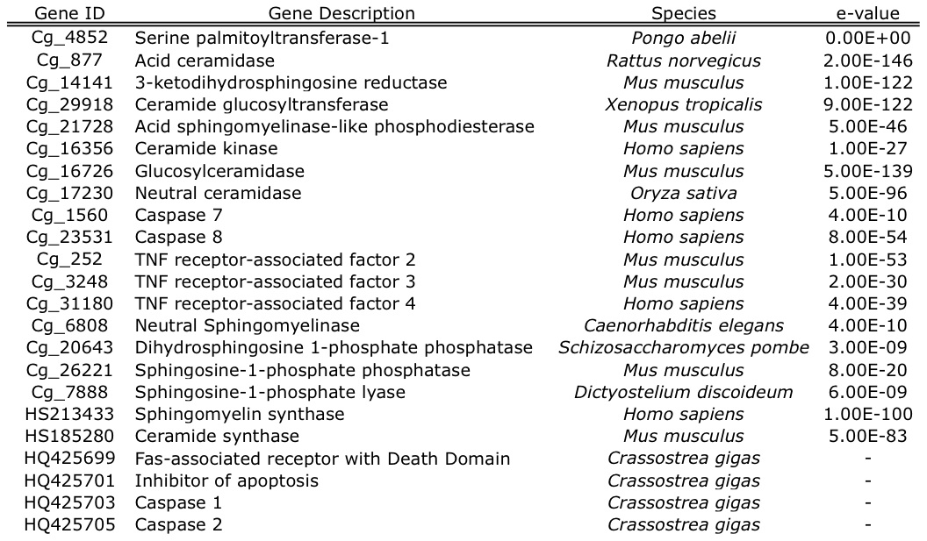
Table 2. Ceramide synthesis and metabolism genes identified in C. gigas through homology searches of publicly available sequences. Sequences assembled from short read archive data and expressed sequence tags were given a contig number that corresponds to the sequence in the supplementary information S1 (“Cg_#”). For each of these contiguous sequences, the top blastx hit and its e-value are provided. Two genes that were identified as a single EST (sphingomyelin synthase and Fas-associated receptor with Death Domain) are listed with their Accession Number, as are the four genes identified by Zhang et al. 2011.

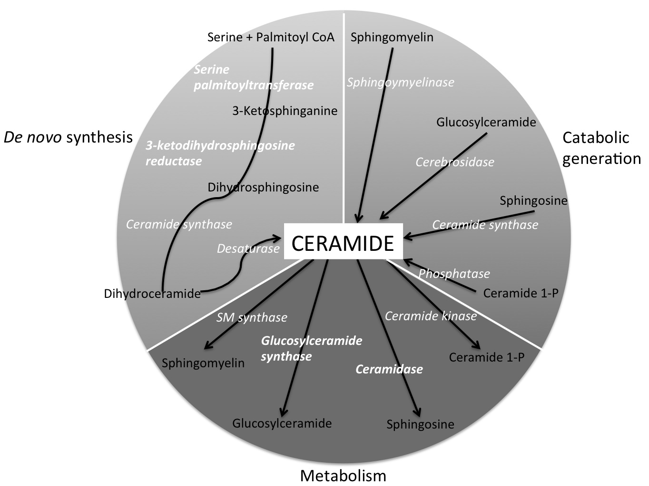
Fig. 1. Representation of the ceramide metabolism pathway. Enzymes are in white italics with the 4 proteins identified as part of this study in bold. Lipids that are either precursors to or the products of enzymatic break-down of ceramide are in black. The pathway is adapted from Ballou et al. (’96) and Hannun and Luberto (2000). Genes listed in Table 2 that are not depicted in this figure are upstream of the ceramide metabolism pathway.

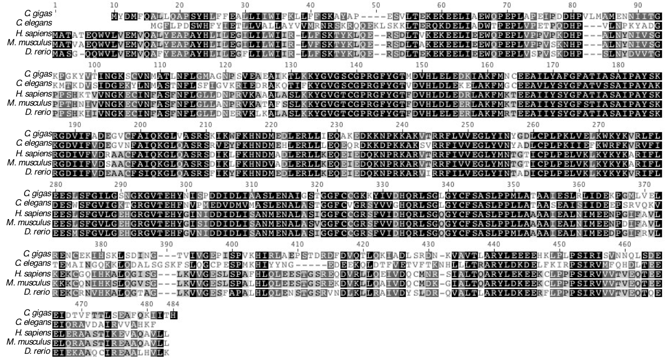
Figure 2. Amino acid alignment of translated Cg-sptlc1 with protein sequence of C. elegans (Accession Number NP_001021978 ), H. sapiens (Accession Number NP_006406), M. musculus (Accession Number NP_033295), and D. rerio (Accession Number NP_001018307). Black shading indicates 100% similarity across sequences, dark gray is 80-100% similarity, light gray is 60-80% similarity, and white is less than 60% similarity. The transmembrane domain is marked by the dashed box and the asparagine that corresponds to the H. sapiens LCB1 isoform is marked with an arrow.

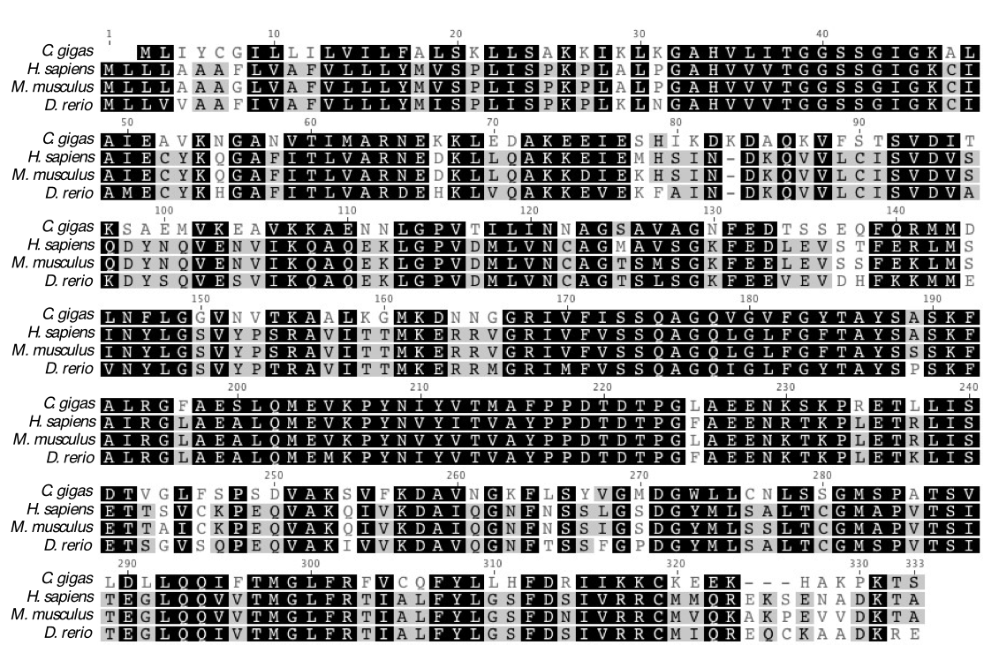
Figure 3. Amino acid alignment of translated Cg-3KDSR with protein sequence from H. sapiens (Accession Number Q06136), M. musculus (Accession Number NP_081810), and D. rerio (Accession Number NP_957433). Black shading indicates 100% similarity across sequences, dark gray is 80-100% similarity, light gray is 60-80% similarity, and white is less than 60% similarity. The conserved catalytic site is marked with an asterix and the NADH/NADPH binding site and active site motif is marked with a diamond.

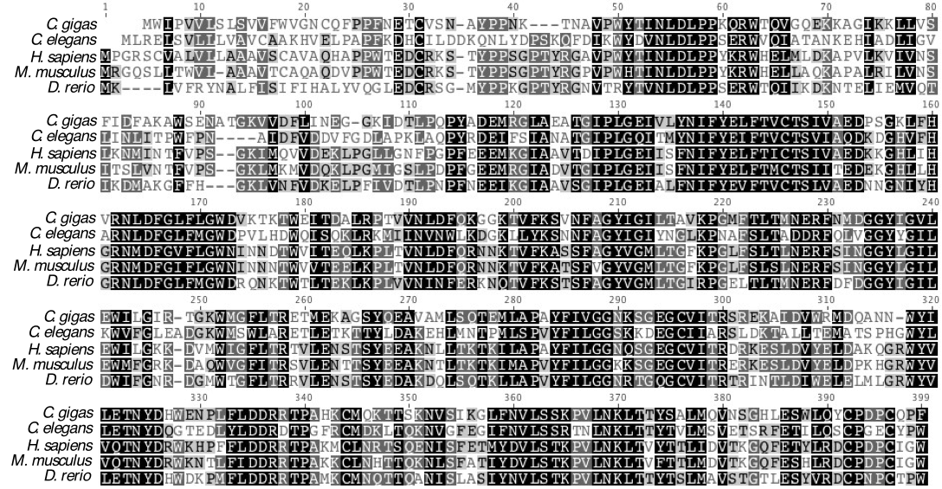
Figure 4. Amino acid alignment of translated Cg-AC with protein sequences from acid ceramidase in C. elegans (Accession Number NP_493173), H. sapiens (Accession Number NP_808592), M. musculus (Accession Number NP_062708), and D. rerio (Accession Number NP_001006088). Black shading indicates 100% similarity across sequences, dark gray is 80-100% similarity, light gray is 60-80% similarity, and white is less than 60% similarity.

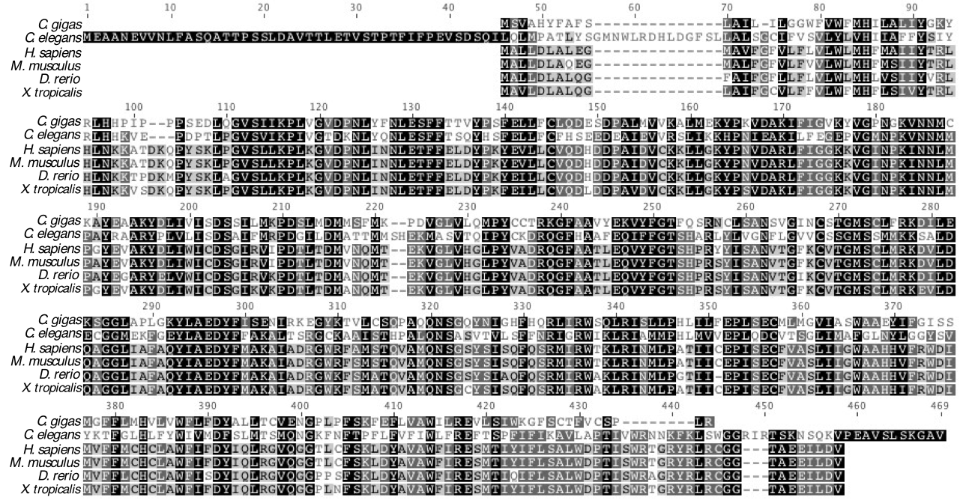
Figure 4. Amino acid alignment of translated Cg-GlcCer with ceramide glucosyltransferase protein sequences from C. elegans (Accession Number NP_506971), H. sapiens (Accession Number NP_003349), M. musculus (Accession Number NP_035803), and X. tropicalis (Accession Number Q5BL38). Black shading indicates 100% similarity across sequences, dark gray is 80-100% similarity, light gray is 60-80% similarity, and white is less than 60% similarity.

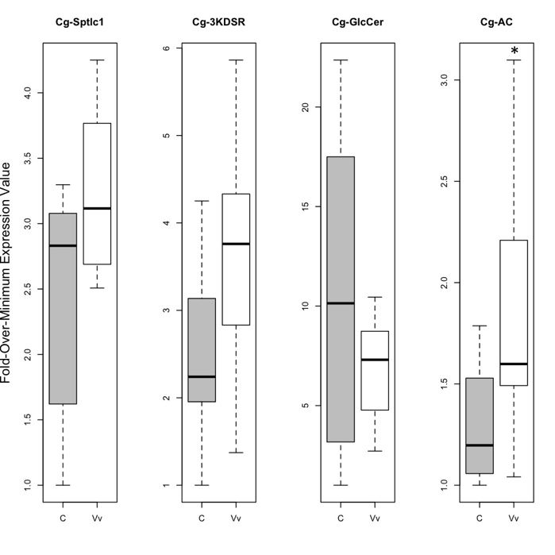
Figure 6. Expression levels in gill tissue for all four genes in control versus V. vulnificus-exposed oysters. Gene expression values for the control (“C”) oysters are represented by the gray boxes, while the V. vulnificus-exposed (“Vv”) oysters are represented with the white boxes. All response gene expression values were normalized to expression of the housekeeping gene, EF1α, and then transformed to fold-over-minimum. The box represents the spread of the middle 50% of the data with the median shown as the horizontal black line in the box. The dotted lines span the remaining data. The only gene that shows a statistically significant difference in expression at α =0.05 is Cg-AC (p=0.045), which is marked with an asterix.

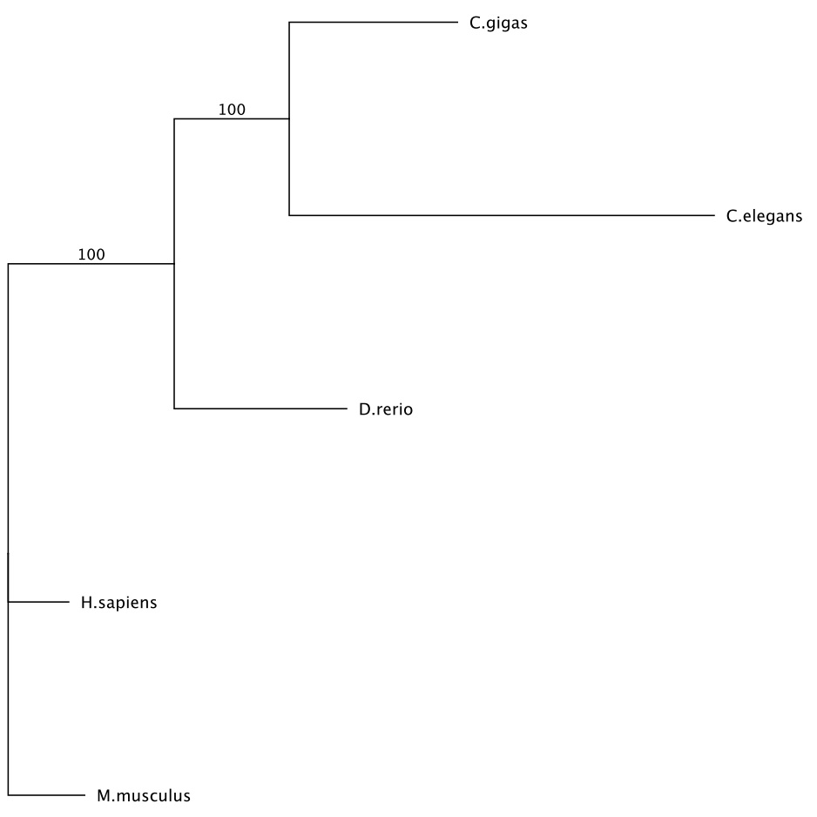
Figure 7. Maximum likelihood phylogenetic tree of the amino acid alignment of acid ceramidase in C. gigas, C. elegans, H. sapiens, M. musculus, and D. rerio. All other protein trees had similar topology to the one shown. The tree was created based on the James-Taylor-Thornton (JTT) model and bootstrapped 100 times.

LITERATURE CITED
Altschul SF, Madden TL, Schaeffer AA, Zhang J, Zhang Z, Miller W, and Lipman DJ. 1997. Gapped BLAST and PSI-BLAST: a new generation of protein database search programs, Nucleic Acids Res. 25:3389-3402.

Ballou LR, Chao CP, Holness MA, Barker SC, and Raghow R. 1992. Interleukin-1-mediated PGE2 production and sphingomyelin metabolism. Evidence for the regulation of cyclooxygenase gene expression by sphingosine and ceramide. The Journal of Biological Chemistry. 267: 20044-20050.

Ballou LR, Laulederkind SJ, Rosloniec EF, and Raghow R. 1996. Ceramide signaling and the immune response. Biochimica et Biophysica Acta. 1301(3): 273-287.

Bernardo K, Hurwitz R, Zenk T, Desnick RJ, Ferlinz K, Schuchman EH, and Sandhoff K. 1995. Purification, characterization, and biosynthesis of human acid ceramidase. The Journal of Biological Chemistry. 270: 11098-11102.

Chavez JA, Holland WL, Bär J, Sandhoff K, and Summers SA. 2005. Acid ceramidase overexpression prevents the inhibitory effects of saturated fatty acids on insulin signaling. The Journal of Biological Chemistry. 280: 20148-20153.

Drummond AJ, Ashton B, Buxton S, Cheung M, Cooper A, Heled J, Kearse M, Moire R, Stones-Havas S, Sturrock S, Thierer T, and Wilson A. 2010. Geneious v4.5.6. Available from http://www.geneious.com

El Babili M, Brichon G, and Zwingelstein G. 1996. Sphingomyelin metabolism is linked to salt transport in the gills of euryhaline fish. Chemistry and Materials Science. 31: 385-392.

Eliyahu E, Park J-H, Shtraizent N, He X, and Schuchman EH. 2007. Acid ceramidase is a novel factor required for early embryo survival. The FASEB Journal. 21: 1403-1409.

Guindon S and Gascuel O. 2003. A simple, fast, and accurate algorithm to estimate large phylogenies by maximum likelihood. Systematic Biology. 52(5): 696-704.

Haimovitz-Friedman A, Kan CC, Ehleiter D, Persaud RS, MclOughlin M, Fuks Z, and Kolesnick RN. 1994. Ionizing radiation acts on cellular membranes to generate ceramide and initiate apoptosis. Journal of Experimental Medicine. 180(2): 525-535.

Hakomori S. 2003. Structure, organization, and function of glycosphingolipids in membrane. Current Opinion in Hematology. 10(1): 16-24.

Hanada K. 2003. Serine palmitoyltransferase, a key enzyme of sphingolipid metabolism. Biochimica et Biophysica Acta – Molecular and Cell Biology of Lipids. 1632: 16-30.

Hannun YA. 1994. The sphingomyelin cycle and the second messenger function of ceramide. The Journal of Biochemical Chemistry. 269(5): 3125-3128.

Hannun YA and Luberto C. 2000 Ceramide in the eukaryotic stress response. Trends in Cell Biology. 10(2): 73-80.

Ichikawa S, Sakiyama H, Suzuki G, Hidari KI and Hirabayashi Y. 1996. Expresion cloning of a cDNA for human ceramide glucosyltransferase that catalyzes the first glycosylation step of glycosphingolipid synthesis. PNAS. 93: 4638-4643.

Ichikawa S and Hirabayashi Y. 1998. Glucosylceramide synthase and glycosphingolipid synthesis. Trends in Cell Biology. 8: 198-202.

Jones DT, Taylor WR, Thornton JM. 1992. The rapid generation of mutation data matrices from protein sequences. Comput Appl Biosci. 8: 275-282.

Kihara A and Igarashi Y. 2004. FVT-1 is a mammalian 3-Ketodihydrosphingosine Reductase with an active site that faces the cytosolic side of the endoplasmic reticulum membrane. The Journal of Biological Chemistry. 279:49243-49250.

Koch J, Gärtner S, Li C-M, Quintern LE, Bernardo K, Levran O, Schnabel D, Desnick RJ, Schuchman EH, and Sandhoff K. 1996. Molecular cloning and characterization of a full-length complementary DNA encoding human acid ceramidase: identification of the first molecular lesion causing Farber Disease. The Journal of Biological Chemistry. 271: 33110-33115.

Larkin MA, Blackshields G, Brown NP, Chenna R, McGettigan PA, McWilliam H, Valentin F, Wallace IM, Wilm A, Lopez R, Thompson JD, Gibson TJ, Higgins DF. 2007. Clustal W and Clustal X version 2.0. Bioinformatics. 23: 2947-2948.

Le Grand F, Kraffe E, Marty Y, Donaghy L, and Soudant P. 2011. Membrane phospholipid composition of hemocytes in the Pacific oyster Crassostrea gigas and the Manila clam Ruditapes philippinarum. Comparative Biochemistry and Physiology – Part A. 159(4): 383-391.

Lee Y, De Zoysa M, Whang I, Lee S, Kim Y, Oh C, Choi CY, Y S-Y, and Lee J. 2011. Molluscan death effector domain (DED)-containing caspase-8 gene from disk abalone (Haliotis discus discus): Molecular characterization and expression analysis. Fish & Shellfish Immunology. 30(2): 480-487.

Li C-M, Park J-H, He X, Levy B, Chen F, Arai K, Adler DA, Disteche CM, Koch J, Sandhoff K, and Schuchman EH. 1999. The Human acid ceramidase gene (ASAH): structure, chromosomal location, mutation analysis, and expression. Genomics. 62: 223-231.

Merrill AH, Nixon DW, and Williams RD. 1985. Activities of serine palmitoyltransferase (3-ketosphinganine synthase) in microsomes from different rat tissues. Journal of Lipid Research. 26: 617-622.

Momany C, Ghosh R, and Hackert ML. 2008. Structural motifs for pyridoxal-5’-phosphate binding in decarboxylases: An analysis based on the crystal structure of the Lactobacillus 30a ornithine decarboxylase. Protein Science. 4(5): 849-854.

Okino N, Xingxuan H, Gatt S, Sandhoff K, Ito M, and Schuchman EH. 2003. The reverse activity of human acid ceramidase. The Journal of Biological Chemistry. 278: 29948-29953.

Perry DK 2002. Serine palmitoyltransferase: role in apoptotic de novo ceramide synthesis and other stress responses. Biochimica et Biophysica Acta – Molecular and Cell Biology of Lipids. 1585(2-3): 146-152.

Perry DK, Bielawska A, and Hannun YA.. 2000. Quantitative determination of ceramide using diglyceride kinase. Methods in Enzymology. 312: 22-31.

R Development Core Team. 2011. R: A language and environment for statistical computing. R Foundation for Statistical Computing. Vienna, Austria. www.R-project.org.

Romero A, Estévez-Calvar N, Dios S, Figueras A, and Novoa B. 2011. New insights into the apoptotic process in mollusks: characterization of caspase genes in Mytilus galloprovincialis. PLoS ONE. 6:e17003. doi:10.1371/journal.pone.0017003.

Rozen S and Skaletsky HJ. 2000. Primer3 on the WWW for general users and for biologist programmers. In: Krawetz S, Misener S (eds) Bioinformatics Methods and Protocols: Methods in Molecular Biology. Humana Press, Totowa, NJ, pp 365-386.

Seo J-K, Stephenson J, Crawford JM, Stone KL, and Noga EJ. 2010. American oyster, Crassostrea virginica, expresses a potent antibacterial histone H2B protein. Marine Biotechnology. 12(5): 543-551.

Strelow A, Bernardo K, Adam-Klages S, Linke T, Sandhoff K, Krönke M, and Adam D. 2000. Overexpression of acid ceramidase protects from tumor necrosis factor-induced cell death. The Journal of Experimental Medicine. 192: 601-612.

Verheij M, Bose R, Lin XH, Yao B, Jarvis WD, Grant S, Birrer MF, Szabo E, Zon LI, Kyriakis JM, Haimovitz-Friedman A, Fuks Z, and Kolesnick RN. 1996. Requirement for ceramide-initiated SAPK/JNK signaling in stress-induced apoptosis. Letters to Nature. 380: 75-79.

Yabu T, Kishi S, Okazaki T, and Yamashita M. 2001. Characterization of zebrafish caspase-3 and induction of apoptosis through ceramide generation in fish fathead minnow tailbud cells and zebrafish embryo. Biochem. J. 360: 39-47.

Yu H, He Y, Wang X, Zhang Q, Bao Z, and Guo X. 2011. Polymorphism in a serine protease inhibitor gene and its association with disease resistance in the eastern oyster (Crassostrea virginica Gmelin). Fish Shellfish Immunol. 30(3): 757-762.

Zhang L, Li L, and Zhang G. 2011. Gene discovery, comparative analysis and expression profile reveal the complexity of the Crassostrea gigas apoptosis system. Developmental and Comparative Immunology. 35: 603-610.

Zhao S and Fernald RD. 2005. Comprehensive algorithm for quantitative real-time polymerase chain reaction. Comput Biol. 12(8): 1045-1062.

